Air Quality Monitoring Lesson

- Definition
  - Direct Contact – the process whereby compressed air is in contact as a part of the production and processing, including packaging and transportation of safe food production.
  - Indirect Contact – the process whereby compressed air is exhausted into the local atmosphere of the food preparation, production, processing, packaging, or storage.
  - Breathing Air – the provision of breathable air to be used by a person in the execution of a work-related task is controlled by certain legal requirements.

- Air Quality Monitoring Program
  - Food and Beverage manufacturing facilities employ the use of compressed air extensively in the plant. As common as this is, the potential hazards associated with this powerful utility are not obvious and apparent. Food hygiene legislation to protect the consumer places the duty of care on the food manufacturer. For this reason, many companies often devise their own internal air quality standards based upon the best practice, as the published collections of Good Manufacturing Practices (GMP) that relate to compressed air are nebulous and difficult to wade through. Understandably this has led to a significant difference in the quality of compressed air used throughout the industry, with major differences even existing in plants owned by the same company.
  - Air is not as clean as it appears to be. Untreated compressed air contains many potentially harmful or dangerous contaminants which must be removed or reduced to acceptable levels in order to protect the consumer and provide a safe and cost-effective production facility.

- Compressed Air
  - Compressed air can be a source of chemical and microbiological contamination.
    - Potential contaminants can include particulates including:
      - Dirt (microorganisms, atmospheric dirt and solid particulates, rust, and pipe scales).
      - Water (water vapor, condensed liquid water, and water aerosols) and oil (oil vapor, liquid oil, and oil aerosols).
    - Food operations must verify and validate that the compressed air used is appropriate and does not serve as a source of contamination. When compressed air comes in contact with an exposed product or direct product contact surfaces, the air compressor must use food-grade oil refer to List for Approved Food Grade Lubricant for Air Compressor.
    - Preventive maintenance programs need to ensure that an appropriate filtration program is in place at the point of use and the filters are cleaned or changed at a frequency appropriate to the product and process or following any maintenance to air supply source or equipment refer to Maintenance for Air Compressor and Filter Changing SOP.
    - Any maintenance must be done in a hygienic manner.
  - Compressed air is used in more than 70 percent of all manufacturing activities, ranging from highly critical applications that may impact product quality.
  - Industrial application for compressed air operates at a pressure of around 7 bar g to 20 bar g (100-300psi), generally considered as low-pressure air.
  - Food hygiene legislation to protect the consumer places the duty of care on the food manufacturer as the published collections of Good Manufacturing Practices (GMPs) that relate to compressed air are nebulous and difficult to wade through (Figure 1).
  - Employing the most critical elements from all of the published GMPs ensures that you have the bases covered for compressed air quality at the point of contact.
  - Using filtration that meets the most discriminating industry standards ensures compliance with ALL of the published GMPs. An outline of published GMPs and standards is shown below:

Table 1. Published Good Manufacturing Practices related to compressed air can be difficult to understand and apply to a food processing facility.
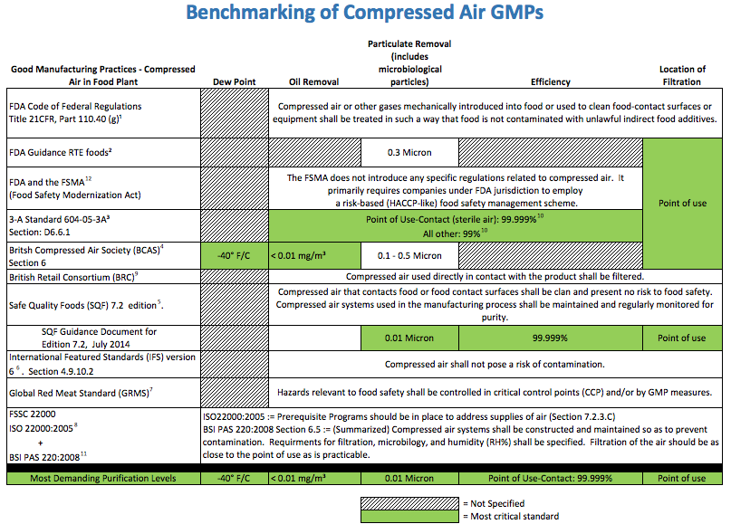

- Potential Risk of Untreated Compressed Air
  - Compressed air is not as clean as it appears to be. Untreated compressed air contains many potentially harmful or dangerous contaminants that must be removed or reduced to acceptable levels in order to protect the consumer and provide a safe and cost-effective production facility.
  - Along with moisture and particulate matter, inlet air to a compressor generally carries 5 to 50 bacteria per cfm. A 75-hp compressor with a capacity of 300 scfm therefore takes in 100,000 to 1 million bacteria each hour.
  - These bacteria get compressed along with the air and begin their journey through the compressed air system. Introducing this type of microbial contamination to food products is very risky and would be considered a lack of control by the facility. Understanding how to integrate the treatment of compressed air in a facility will help ward off that risk.

- Contaminants in Compressed Air
  - Compressed Air & Gas Institute (CAGI) cites 10 contaminants that typically need to be removed or reduced from low-pressure compressed air used for manufacturing (not breathing air). These contaminants fall into four general categories:
    - Some examples of direct and indirect contact points are:
    - Particles (from pipe scale, wear particles and atmospheric dirt)
    - Water (liquid, vapor, and aerosol)
    - Oil (liquid, vapor, and aerosol)
    - Microorganisms
  - Direct and Indirect Contact
    - Food Manufacturers will identify compressed air used directly and/or indirectly on or in the product. Some Direct Contact examples include compressed air that is used to mix, cut, move, sort or clean product. Some Indirect Contact examples include cleaning surfaces the product touches, opening packaging the product goes into, belts that move the product, and pneumatic exhaust that may come into contact with the product.
    - Some examples of direct and indirect contact points are:
      - Bagging
      - Sparging/Mixing
      - Drying
      - Air Knives
      - Pneumatic Exhaust (i.e., cylinder exhaust)

- Contamination Sources
  - The last thing any manufacturer wants to do is issue a recall. Compressed air, if properly filtered, maintained, and monitored is a safe utility that is used in numerous manufacturing processes. However, when compressed air purity or compressed air quality is overlooked, it can be a contaminant to your product. Common sources of contamination not only include the compressor, but the intake air, piping, and storage. Ultimately, contamination can come from any number of places.
  - Sources of Contamination in Manufacturing
    - Hazards in the form of contamination are typical present in compressed air system. There are 10 main contaminants that require treatment if the system is to operate safely, efficiently and cost effectively. Contamination in compressed air system comes from four different sources show in figure 1.
Figure 1. The sources of contaminants can travel from ambient air all the way through the compressed air system

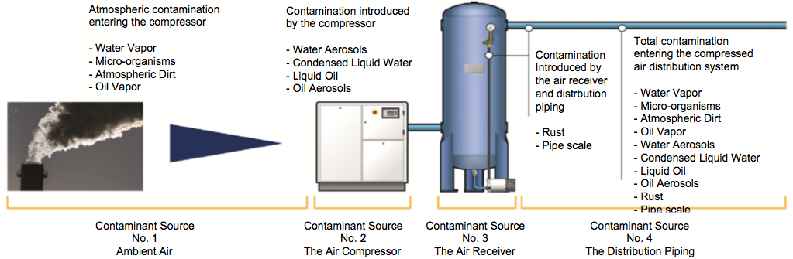
  - Intake Air
    - Intake Contamination may Include:
      - Particles (viable & nonviable)
        - Ambient air is subject to contamination which affects the quality of generated compressed air. This can include particulate matter containing viable and non-viable microbiological organisms. For examples, in a typical industrial environmental there can be more than 140 million dirt particles in every cubic meter of air. Consider that, when this is then compressed on average to 7 bar g, the contamination is considered in the line with the pressure increase. The compressor intake filter will remove some of this contamination, the fact remains that around 80 percent of these particles are smaller than two microns in size and will pass directly into the compressed air system.
      - Water Vapor (Vapor, Liquid and Aerosols).
        - Water vapor enters the compressed air from the compressor intake. In total volume terms, condensed water vapor is the most prominent contaminant in the compressed air system and on investigation, will form much of the liquid contamination found in a compressed air system.
      - Oil Vapor (Vapor, Liquid and Aerosols)
        - Oil Contamination in the compressed air system can enter from two separate routes. The first of these is driven by the quality of the intake air. Even before compression begins, the air drawn in through the intake of a compressor contains hydrocarbons and VOC (volatile organic compounds) which when compressed, regardless of compressor type, will cause oil to be present in the compressed air system. Airborne hydrocarbon and VOC are common and are more prevalent in urban and industrial areas. One of the most common sources of hydrocarbons and VOC is fossil fuel, which when condensed and cooled will form a liquid contaminant in the system. Other source of oil is from the compressors own lubrication system.
  - Contaminants Created by the System Itself
    - Wear Particles
    - Intake Water can cause corrosion
    - Damaging equipment
    - Promote microbial growth
    - Ruin the final product
    - Oil-free Compressors still have oil issues from oil introduced by the intake
    - Gases Possibly Created by the Compressor
      - Carbon Monoxide
      - Carbon Dioxide
      - Gaseous Hydrocarbons
    - The compressor, if oil lubricated, can add oil in the form of liquid, aerosol, or vapor. Any compressor that is improperly maintained can be a source of contamination. Other sources of contamination include the system piping and air storage receivers.
    - New piping should be tested to assure that it has been properly purged of potential contaminants such as particulates, solders, or glues used during installation. Older piping can have an accumulation of water, rust, and oil. When connecting new piping to an older piping distribution system, the jarring of the old piping can cause particulates (such as rust, pipe scale, dirt, metal oxides, etc.) to be loosened and introduced into the new piping. Storage receivers with excess water (vapor, liquid, or a mixture of oil and water) can become a breeding ground for microorganisms.

- Air Quality Contamination in Food Packaging
  - Packaging
    - The food industries are focusing more attention to the utilities used in the manufacturing process. Although long overlooked, compressed air quality is making its way under the microscope.
    - Compressed air & gas sources of contamination in food packaging.
    - Food Packagers should identify compressed air used directly and/or indirectly on or in the product. Packaging generally falls under the indirect contact category. Compressed air can be used to make the actual package as in blow molding, clean a surface that the product is placed on prior to packaging, or clean the package prior to the final product going into the package.
    - These are just a few examples of how compressed air can be used in the packaging process. The use of compressed air covers the gamut of packaging materials from glass, plastic, metal, Styrofoam™, paper products and more.

- Managing the Risk of Compressed Air in Food Processing
  - Compressor room drying and filtration are good, but they are not enough for a food processing plant if it is sufficient for the recommended final stage of filtration in these food contact areas will have a rating of 0.01 micron with an efficiency of 99.999% (or as determined by appropriate risk analysis)
  - System filtration can do a good job reducing the number of contaminants introduced into the downstream distribution system. However, that alone does not meet the requirements of the published GMPs that address compressed air nor is it fully effective.
  - The published GMPs call for point-of-use filtration that will be in place for all points where compressed air either directly or indirectly contacts food.

- Prevention the Growth of Microbes
  - The warm, dark, moist environment inside a compressed air system is the perfect condition for microbes to flourish and grow.
  - Drying the air to a low dew point is an effective way to inhibit this microbial growth. Inhibit, not kill.
  - Microbes need food, water, and the right temperature to grow. Take one or two of those nutrients away, and the growth stops temporarily.
  - Some of the microbial pathogens that are hazards to food safety form spores and/or protect themselves by moving into a dormant stage when nutrients in the surrounding environment are depleted. These dormant spores resume propagation as soon as the missing nutrients (moisture) become available again through contact with the food.
  - Bacterial spores survive very dry conditions without any problem.
  - Vegetative bacterial cells can survive dried states for a period of time. In fact, lyophilization (freeze drying) is a common way to preserve bacteria.
  - Once conditions are favorable for growth (moisture, nutrients etc.), the bacteria can grow again. The foodborne pathogen Salmonella is notorious for surviving under water limited conditions.
  - The best practice for food safety is to first dry the air, and — more importantly — use point-of-use filtration to capture the microbes and spores, so they never come in contact the food.

- Monitor Compressed Air for Purity
  - Testing the purity of compressed air coming in contact with food is a best single test at one point in time but is not enough.
  - Compressed air systems are dynamic, and the compressor intake is subject to microbial, particulate, and moisture variations throughout the year as well as buildup of contamination in the system.
  - In addition to testing at the compressed air’s point-of-food contact for pathogenic/allergenic contamination, it is also advisable to test the compressed air for yeast and mold spores where the product is packaged. Many companies find that yeast and mold spores from compressed air introduced in their final packaging operations can be one of the culprits impacting shelf life. Potato dextrose agar is best for testing for the presence of yeast and mold spores in the compressed air.
  - Figure 2 Example for Compressed Air Microbial Test Unit (CAMTU) lightweight, easy to use device capable of sampling compressed air systems for microbes. The unit requires no electricity and has a quick sampling time of 20 seconds.
  - Figure 2 Examples for Compressed Air Microbial Test Unit (CAMTU)
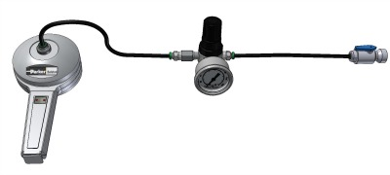
  - Figure 3 Agar plate offers greater dispersion of the compressed air over the agar as a result of an improved air flow path through the center hole in the plate. This provides optimum detection performance and enhanced capture of microbes.
  - Figure 3 Example of Agar plate offers greater dispersion of the compressed air
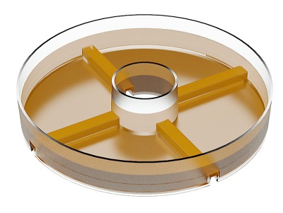
- System Design GMP: Point-of-Use Filtration
  - Point-of-use filtration is the best line of defense against microbial contamination of food in a compressed air system. Even the best compressor room system filtration does not eliminate harborage sites and biofilm buildup in the downstream compressed air piping system. The following three stages of filtration will significantly reduce the risk of microbial contamination of the food.
    - Remove bulk liquid and particulate matter down to 0.01 micron at ≥ 93% coalescing efficiency.¹Automatic drain in filter.
    - Remove oil and water aerosols and smaller particulate matter down to 0.01 micron at ≥ 99.99% coalescing efficiency. Automatic drain in filter.
    - If there is a concern for hydrocarbon vapor carryover from the air compressor, then the installation of activated carbon filter may be necessary.
    - Remove microbial contamination down to 0.01 micron at ≥ 99.999% particulate removal efficiency¹⁰ (5-log reduction) with a sterile air filter.

- Verification and Validation – Procedure
  - Testing the compressed air-filtration control system is collected by QA using 3rd party laboratory instructions.
  - Test requirements and number of samples will be based on the risk to the product and process
  - Microbiological testing can include testing for APC (aerobic plate count) and/or indicator organisms as appropriate to the operation refer to Quality Monitoring Sampling Procedure -Microbiological Testing.
  - Testing for moisture is to be considered if moisture is a potential risk to the product (e.g., dry operations) refers to Quality Monitoring Sampling Procedure -Chemical and Other Contaminants Testing.
  - Sampling area should be Restricted to other Employees for tag refer to Air Quality Monitoring Tag.

- Frequency
  - Preventive Maintenance for Air Compressor will be every semi-annual or depend on supplier recommendation refer to Maintenance for Air Compressor and Filter Changing SOP.
  - Changing of Air Compressor Filter refer to Maintenance for Air Compressor and Filter Changing SOP.
  - Pre-Operational Cleaning and Sanitation refer to Pre-Operational Cleaning Procedures - Air Generator and Compressor Unit SOP.
  - Microbiological testing for APC and TPC will be annually referred to Quality Monitoring Sampling Procedure -Microbiological Testing.
  - Chemical and Other Contaminants Testing will be annually referred to Quality Monitoring Sampling Procedure -Chemical and Other Contaminants Testing

- Controls and Frequency
  - A point of use filter – 0.01 micron
  - Frequency of filter changes refer to Maintenance for Air Compressor and Filter Changing SOP
  - Validation from the filter manufacturer is considered adequate validation.
  - Air out put must be dry as an indicator of control failure.

- Review – QA
  - The condition of air compressors and compressed air used to transport product, or otherwise to come into contact with exposed product, product contact surfaces or packaging materials.
  - Filters are checked or changed at a frequency based on the air quality program.
  - The site has a standard for microbiological purity of compressed air that contacts foods as well as a process for testing;
  - Maintenance staff has the data specification sheet for the filter housing;
  - Follow up with preventative maintenance and SSOPs;
  - Performance characteristics of the filter in place must match the risks identified in the site’s assessment.
  - Identification of the level of filtration at the point-of-use for commercially sterile air.
  - Compressed air that is in contact with food is checked for purity using methods and at a frequency based on the air quality program and test procedures.

- History
Revision No.: | Revision Date: | Description of Change: | Originator / Author Name: | Title / Department:
0 | 20230110 | Original | Arnel Ryan | PCQI / Compliance

Requirements:
- The trainee (employee/visitor) has read or received a verbal translation of all or part of the policy, procedure, method, and/or SOP for which they are being trained.
- The trainee has observed a demonstration of the task they are to perform or the procedure for which they are being trained as required.
- The trainee has demonstrated the ability to perform the task with acceptable proficiency and minimal supervision.

